**Kidney Stones Detection using Image Processing & Deep Neural Networks**

**Sai Manohar Vemuri, Student, Sagi Rama Krishnam Raju Engineering College, Bhimavaram, India, vemurimanohar6642@gmail.com**

**Kolli Sesha Shai Datta, Student, Anil Neerukonda Institute of Technology & Sciences, Visakhapatnam, India, seshudattakolli123@gmail.com**

**Pavan Sai Vatrapu, Student, Gayatri Vidya Parishad College of Engineering, Visakhapatnam, India, pavansaivatrapu7159@gmail.com**

**Abstract** Kidney Stones have been a big problem in recent years, and if not found early, they can cause difficulties, necessitating surgery to remove the stone. Volumetric measurements of kidney stones are more useful and repeatable than linear measurements, according to previous research. Deep Learning-based algorithms that use non-contrast abdominal computed tomography (CT) scans may help detect stones and reduce the workload associated with manual detection. A dataset of CT scans is used to identify the stone, which includes CT scans with and without manually indicated kidney stones. After performing image processing techniques on the raw CT scan images, Random Search algorithm is implemented to find the optimal parameter values for the deep learning model. This model has acquired an accuracy of 98.1%.

*Keywords* —*Computed Tomography (CT), CNN, Hyperparameter Tuning, MedianBlur, OpenCV, Random Search, Relu, XResNet50*

# **Introduction**

The prevalence of kidney stone illness is rising these days. Renal calculus, often known as a kidney stone, is a solid mass that forms in the kidneys. Kidney stones can affect anyone, including children, and the majority of cases go unnoticed unless there is severe abdominal pain or an odd urine color. Fever, discomfort, and nausea are some of the symptoms that persons with this issue may experience. Small ureteral stones may usually pass on their own, but larger stones may require interventional therapy such extracorporeal shock wave lithotripsy or endoscopic lithotripsy. The early stages of many kidney stone disorders are not observed until later or are difficult to detect, causing harm to the kidney as they get larger. Diabetes, hypertension, and glomerulonephritis are the leading causes of kidney failure, with millions of people affected each year. Based on the location, kidney stones are classified as kidney (nephrolithiasis), ureter (ureterolithiasis) and bladder (cystolithiasis). Imaging is becoming an important part of biological and clinical research. Medical imaging is a method of creating a visual picture of the inner organs by a clinician. They're then employed for clinical research and medical intervention. Ultrasound (US) images, Noncontrast Computed Tomography (NCCT or CT-Scan), Magnetic Resonance Imaging (MRI), and X-ray are now available options. For the diagnosis of acute flank pain, NCCT is widely used. So, detecting the stone and doing so precisely opens the door to image processing, because image processing has the potential to produce precise findings without the need for human participation. To detect the stone from a Computed Tomography image, radiologists typically employ a manual procedure.These advantages have resulted in an increase in the use of CT for suspected urolithiasis, but they have also contributed to an increase in imaging volume, longer turnaround times, higher radiologists' workload, and longer hospital admissions. This work used KUB (Kidney-urine-belly) CT scans to construct a semi-automatic kidney screening tool that included digital image processing approach. Deep Learning models have been successfully used in a wide range of applications, including image segmentation, classification, and detection in medicine. In the field of urology, DL techniques are used to automatically detect ureteral and kidney stones. The CT scan information is a grayscale 3D image in which the value of each pixel is directly tied to the sort of substance that occupies that location. The value of the pixels occupied by a kidney stone can occupy a specific range since kidney stones are formed of a certain collection of chemicals. However, different types of components in the human body are constructed of this specific mix of materials. The concentrations of bones and other materials had pixels in the same range as kidney stones.

# **Literature Survey**

Stalina S et al. [1], have performed Image processing techniques on CT Scan images. The author stated that image processing is performed using filtering and image enhancement. Filtering is done to smoothen the image. There are various filters such as Average filter, Weighted Average filter. Gaussian filter, Median filter. In this paper the author has applied Median filter because it is the best method to remove the impulse noise or salt and pepper noise. Image Enhancement technique is used to modify the intensities of the image. CT Scan images are of low quality and hence Image Enhancement should be done. The author has performed Histogram Equalization which modifies the pixel intensity. For Image Segmentation process, the author used Thresholding technique for the partition of image into different regions to extract the desired features.

Kadir Yildirim et al. [2], have gathered 500 NCCT pictures from patients admitted to Elâz Fethi Sekin City Hospital in Turkey for urinary stone illness. The experts completed the labelling procedure by indicating whether or not there are stones. To avoid the overfitting problem, data augmentation techniques were applied to the raw photos. For the kidney stone detection training, XResNet-50 model was used. Fastai (v2) library created on Pytorch deep learning framework was used to train the XResnet-50 model. Adam Optimizer and Cross-Entropy Loss Functions were used to alter the parameters of the XResnet-50 model. The model can display the locations where the DL model focused for classification. According to this article, the tip of the lower pole of the kidney entering the cross-sectional area may have caused the model to produce incorrect results.

Anushri Parakh et al. [3], have evaluated the performance of pretrained models enriched with labeled Unenhanced abdominopelvic CT images across different scanners. All the images were first processed by several Image Processing techniques and then normalized such that all scans were oriented in upward position. Then the images were converted into grayscale. The images were then used for developing a cascading model consisting of two CNNs. The first (CNN-1) model consists of pre-trained models such as ImageNet and GrayNet. During the training process the images were first fed to CNN-1 which helps in identifying the urinary tract and were then presented to CNN-2 for classification into presence or absence of stone.

# **Methodology**

## Gathering Data:

The process of gathering the dataset depends upon the type of problem we are trying to solve. As this project is mainly focused on Image Classification, we need to acquire the required resources from open-source websites such as Kaggle, Github etc. The dataset was uploaded to the Github repository and available in the following link:

<https://github.com/mvemuri6642/Kidney_Stone_Detection_DeepLearning/tree/main/CT_SCAN>

## Data Pre-Processing:

Data Preprocessing is a crucial step when you’re dealing with Image Datasets. We use OpenCV to read the images from the Hard Disk. It contains around 1700 images in two different folders with class labels. As the images are of variable size, we need to convert them into fixed size. The dataset contains two folders “Kidney_Stone” and “Normal”. As the images doesn’t contain any label, we use these folder names to classify the images for training the Deep Learning Model. We resize all the images into 128 x 128 pixels. We then convert the image into Numpy array with the class label. We split the data into 90% for the training and 10% for testing the model.

## Image Processing:

Image Processing is divided into 2 modules:

**Image Pre-processing:** It is basically one of the critical tasks because CT Scan images may have noise. In this operation we apply methods to enhance and filter the image using the Median filter and Power Law Transformation.

Median Filter: Python OpenCV provides the cv2.medianBlur() function to blur the image with a median kernel. This is a non-linear filtering technique. It is highly effective in removing impulse noise and salt-and-pepper noise. This takes a median of all the pixels under the kernel area and replaces the central component with this median value. Figure 1 illustrates the median filter example.

Syntax: *cv2.medianBlur(image,ksize)*

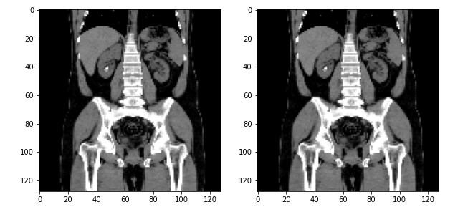

**Figure 1:** Median Filter

Salt and pepper noise has corrupted the above-described figure. The impulse noise is filtered using the median filter. The enhanced image in this case has a noticeable quality enhancement and appears to have been smoothened, which has the effect of reducing high frequency information and enhances the edges of the image [12].

Power Law Transformation: This method is better option for image enhancement. Here, the value of constant should be assumed on the basis of trial-and-error method. Gamma correction is useful when you want to change the contrast and brightness of an image. By taking gamma value=2.5, we get desirable output.

The general form of Power law transformation function is as follows:

s = c * ry

where 'c' and 'y' are the positive constants, and's' and 'r' are the output and input pixel values. The image is converted to the dark side if y>1.

*gamma_corrected=np.array(255*(res / 255) ** 2.5, dtype = 'uint8')*

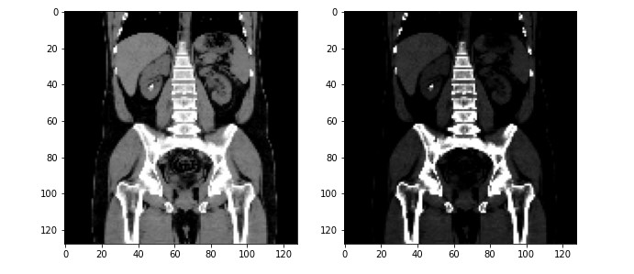

**Figure 2:** Power Law Transformation

**Image Segmentation:** Image Segmentation means to partition the image into different regions to extract relevant information. Segmentation is a vital aspect of medical imaging. It aids in the visualization of medical data and diagnostics of various diseases. Thresholding Method is applied on the image resulting from gamma adjustment to allow segmentation of image the foreground (stone and bones) and background. Thresholding value is based on the intensity of the pixel and intensities below this level becomes zero. Thresholding value is taken as 100. using an appropriate threshold T:

*g(x,y) = $\left\{\begin{aligned}1, if f\left(x,y\right)>T \\ 0, if f\left(x,y\right)≤T\end{aligned}\right.$*

*syntax: ret,thresh1 = cv2.threshold (img ,100 ,255, cv2.THRESH_BINARY)*

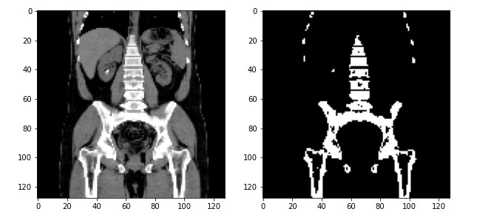

**Figure 3:** Thresholding

## Building Deep Learning Model:

Convolutional Neural Networks (CNN) model is used for training a model. A Convolutional Neural Network, or CNN, is a deep learning neural network designed for processing structured arrays of data such as images. We use Hyperparameter Tuning method to find the model parameters. This is nothing more than looking for the suitable hyperparameter to achieve great precision and accuracy and for that we are going to use Random Search Algorithm. We are running 20 epochs to fit the model with our training data. Here, the architecture we are using is 2-D CNN layer along with RELU (Rectified Linear Unit) activation function. The input frame to this layer is of dimensions 128x128. The below Fig 4 represents the model architecture. In between each Convolutional Layer, we are using max pooling layer to reduce the dimensionality of the feature maps. Dropout layer is used drops neurons from the neural network or ignores them on a temporary basis during training, which helps prevent overfitting problem.

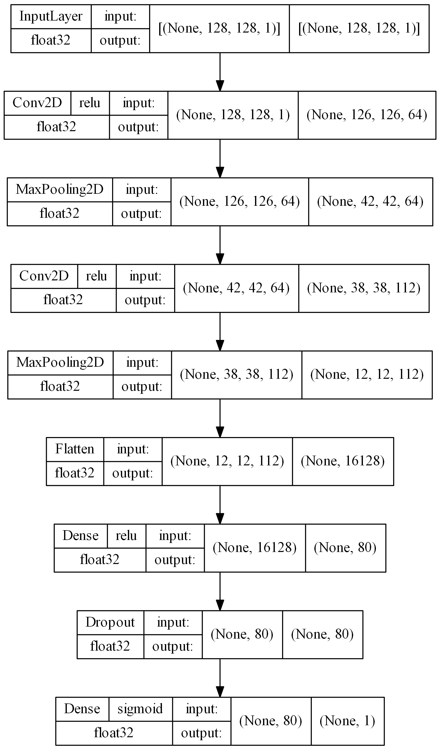

**Figure 4:** Model Architecture

## Training and Testing:

After finding the optimal parameters, we compiled our model with RMSprop optimizer. We fit our model for 20 epochs with a validation split of 0.1 and batch size of 100. This model has acquired an accuracy of 93.1 on the validation data.

## Model Saving:

Random Search algorithm randomly chooses different parameters every time we run the code. After Identifying the best parameters using Random Search, we need to save the model using keras.models module.

Syntax: *model.save(‘/path’)*

Best parameters will be saved in file and can be used for further testing. We don’t need to train every time in order to test the data. We can just load the model and use predict method to get the desired output.

Syntax: *keras.models.load_model(‘/path’)*

# **Results**

Metrics helps in analyzing, measuring the performance quality of machine learning models in different areas such as efficiency and error proneness by using Accuracy, Precision, Recall, F1 score and specificity values. After splitting the dataset into train and test, we performed testing on 161 unseen images and the results are shown in the below Fig 6 which represents the confusion matrix. Confusion matrix is a NxN matrix which is used to describe the performance of the model while solving classification problems. It is used for both binary classification and multiclass classification. In order to create confusion matrix, we need to import metrics from sklearn module.

Syntax: *sklerarn.metrics.confusion_matrix(actual,predicted)*

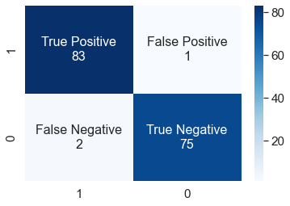

**Figure 6:** Confusion Matrix

Accuracy is a common evaluation metric for classification problems. It’s the number of correct predictions made as a ratio of all predictions made. The percentage of correct predictions for the test data is known as accuracy.

*Accuracy = $\frac{(TP + TN)}{TP + FP + FN + TN}$* = $\frac{\left(83+75\right)}{\left(83 + 1 + 2 + 75\right)}$ = 98.1%

The precision is calculated as the proportion of correctly classified positive samples to all positively classified samples (either correctly or incorrectly).

*Precision = $\frac{TP}{TP+FP}$* *= $\frac{83}{83+1}$* *= 0.988 ≈ 98.8%*

The Recall is calculated as the proportion of correctly classified positive samples to total number of positive samples. It is used to measure the model’s ability to detect positive samples.

*Recall = $\frac{TP}{TP+FN}$* *= $\frac{83}{83+2}$* *= 0.976 ≈ 97.6%*

The F-score or F1-score, is a measure of a model’s accuracy on the dataset and two important components of the F1 score are precision and recall. The precision and recall measures should be combined into one statistic using the F1 score. The F1 score has also been created to function well with unbalanced data.

*F1 Score = $2*\frac{Precision*Recall}{Precision+Recall}$* *= $2*\frac{98.8*97.6}{98.8+97.6}$* *=* 98.1%

## Testing on Unseen Data:

We separated 18 images from the original dataset before feeding them to the model for training. These images will be used for testing. Fig 7 and Fig 8 shows the outputs we got when we tested them on unseen data without any labels.

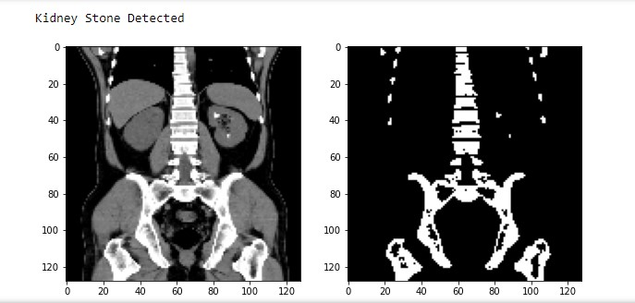

**Figure 7:** Output Screen (Kidney Stone Detected)

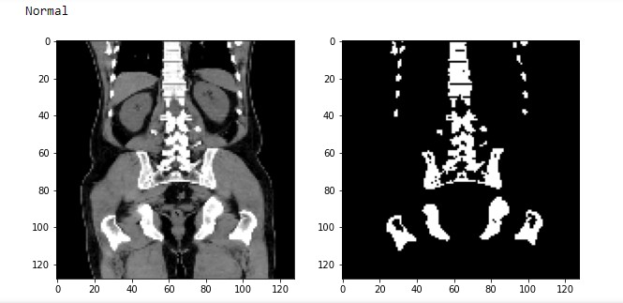

**Figure 8:** Output Screen (Normal)

## Testing on Random Image from Internet:

We tested the model using the image found in the web and it showed the accurate results. Fig 9 shows the output (Abnormal) when we fed random image from web to the model. The following is the URL link to the picture:

<https://www.renalandurologynews.com/wp-content/uploads/sites/22/2019/01/6cmlowerpolerrenalmassqu_1088120.png>

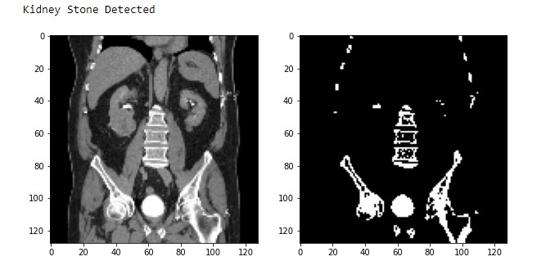

**Figure 9:** Output Screen (Image from Web)

The XResNet50 has acquired an accuracy around 96 percent [2] and the CNN model we created by using Hyperparameter Tuning has achieved an accuracy around 98 percent. The CNN is trained with the images after applying the image processing techniques on them. After performing the image processing, all the noise is removed and segmented. As these pre-trained models doesn’t work with gray-scale images, we need to again convert them into 3 channel images to train a model. In order to overcome this issue, we created our own model using Hyperparameter tuning method. Even then our model has acquired better results when compared to pre-trained models. The below Fig. 10 shows the comparison between accuracy of the existing and proposed models.

**Figure 10:** Accuracy Comparison

# **Conclusion**

An efficient automated system has been developed for identification of Kidney Stones. Convolutional Neural Network is used in designing of the system. With help of image processing, important features are extracted for classification thus it helped to reduce the processing time of the detection system. Median filter is used to remove the ‘salt and pepper’ noise whereas Power Law Transformation is used to adjust contrast and brightness of the image. Thresholding method is the simplest segmentation method where pixels are partitioned depending on their intensity values. We used Hyperparameter tuning method to find the optimal parameters for the Convolutional Neural Network (CNN) model. The model has acquired an accuracy of 98.1%, precision score of 98.8%, Recall score of 97.6% and F1-score of 98.1%.

**References**

1. Stalina S, Aditi S, Anuja R, Prof. Pooja L Gohel, “Kidney Stone Detection Using Image Processing on CT Images”, ISSN NO: 2249-7455
2. Kadir Yildirim, Pinar Gundogan Bozdag, Muhammed Talo, Ozal Yildirim, Murat Karabatak, U.Rajendra Acharya, “Deep learning model for automated kidney stone detection using coronal CT images” , 2021.
3. Parakh, A., Lee, H., Lee, J. H., Eisner, B. H., Sahani, D. V., & Do, S. (2019). Urinary stone detection on CT images using deep convolutional neural networks: Evaluation of Model Performance and generalization. Radiology: Artificial Intelligence, 1(4).
4. Längkvist, Martin & Jendeberg, Johan & Thunberg, Per & Loutfi, Amy & Lidén, Mats. (2018). “Computer aided detection of ureteral stones in thin slice computed tomography volumes using Convolutional Neural Networks” Computers in Biology and Medicine.
5. Nagireddi Amrutha Lakshmi, Bodasakurti Jyithirmayi, Manjeti Sushma, Attaluri Sri Manoj, G. Santoshi, “Kidney Stone Detection from Ultrasound Images by Using Canny Edge Detection and CNN Classification”.
6. Verma, J., Nath, M., Tripathi, P. et al. Analysis and identification of kidney stone using Kth nearest neighbour (KNN) and support vector machine (SVM) classification techniques. Pattern Recognit. Image Anal. 27, 574–580 (2017).
7. Daniel C. Elton, Evrim B. Turkbey, Perry J. Pickhardt, Ronald M. Summers “A deep learning system for automated kidney stone detection and volumetric segmentation on noncontrast CT scans” 2021.
8. Prema T. Akkasaligar, Sunanda Biradar, Veena Kumbar “Kidney stone detection in computed tomography images” IEEE 2017.
9. Mehmet Baygin, Orhan Yaman, Prabal Datta Barua, Sengul Dogan, Turker Tuncer, U. Rajendra Acharya “Exemplar Darknet19 feature generation technique for automated kidney stone detection with coronal CT images” 2021.
10. A.Nithya,Ahilan Appathurai, N.Venkatadri,D.R.Ramji, C.Anna Palagan “Kidney disease detection and segmentation using artificial neural network and multi-kernel k-means clustering for ultrasound images” 2020.
11. M.Akshaya, R.Nithushaa, N.Sri Madhava Raja, S.Padmapriya “Kidney Stone Detection Using Neural Networks” IEEE 2020.
12. M.S.Abirami, T.Sheela, “Improved Speedup Performance in Automated Segmentation of Kidneys on Abdominal CT Images and Extracting its Abnormalities” IJPAM 2017.
13. Saman Ebrahimi, Vladimir Y. Mariano “Image Quality Improvement in Kidney Stone Detection on Computed Tomography Images” Journal of Image and Graphics, Vol 3, No. 1, June 2015.